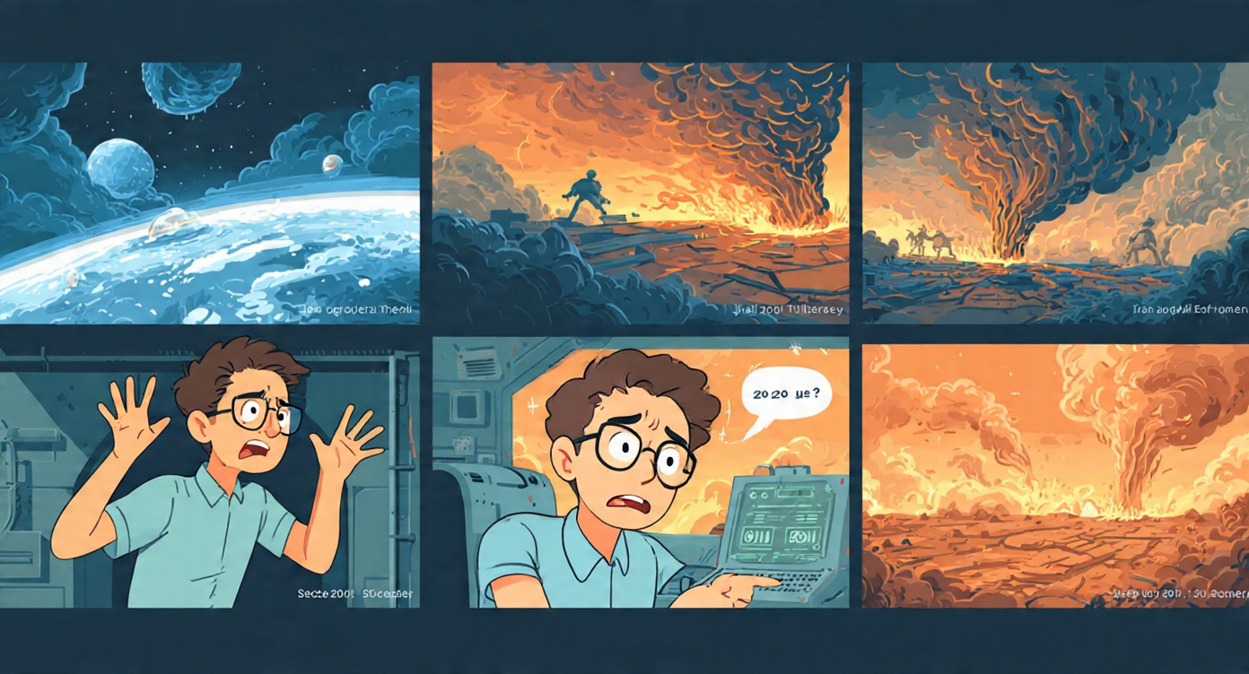
ACT 1 – PROLOGUE: THE BURNED PLANET (0:00–0:45)
Scene 1 (0:00-0:25) – Void
- Visual: Deep blue, white cutout cracked Earth.
- Kai VO: "2147. We didn't lose to climate. We lost to bad choices."
- Camera pushes into crack.
Scene 2 (0:25-0:45) – The Warp
- Inside: Kai in time-pod, pulls lever.
- KAI : "I'm going back to learn why we choose wrong."
- Portal flashes — he disappears.

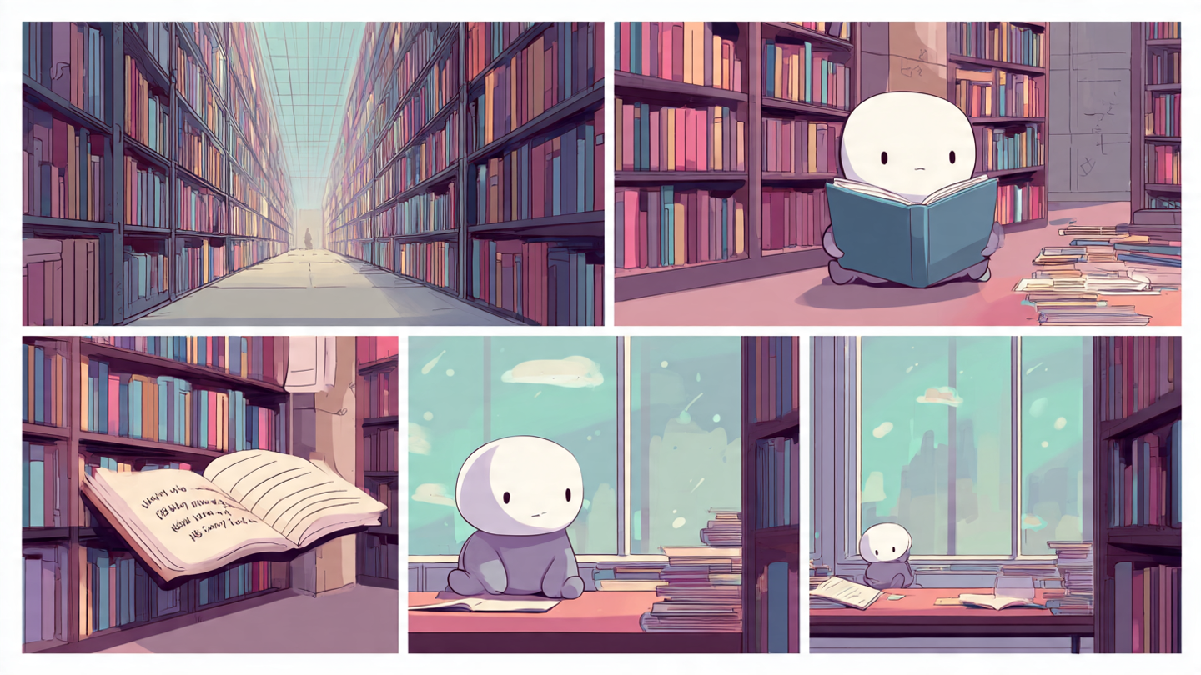

CT 2 – THE LIBRARY (0:45–2:00) your new version
Scene 3 (0:45-1:05) – Arrival
- Kai crashes into an old university library in 2025
- A thick book drops on his head. Title in hand-lettering: "How to Understand Whatever Reason"
Scene 4 (1:05-1:30) – The Book
- He opens it, pages flip in cutout style:
  - Page 1: "Policy Analysis" – find what people fundamentally want, not what they say
  - Page 2: "Policy Design" – test "what if" before you act
  - Page 3: "Tool: Structural Estimation" – Static model (one choice) / Dynamic utility model (choices over time)
- VO: "So economists don't guess. They build models of hidden wants."
Scene 5 (1:30-1:50) – Reading Montage
- Kai read that book beside the table. Window behind him loops fast: daylight → night → daylight → night. Pages turn. Shows hours passing.
- he’s learning the framework.
Scene 6 (1:50-2:00) – The Bump
- He stands, walks out door with book under arm, bumps into a young woman.
- Kai: "Mara?!"
- She steps back, scared: "Sorry— do I know you?"
- Kai freezes (thought): "In 2025 she doesn't love me yet. What did I do wrong? I need to study what make she love me again , like finding hidden preferences that I read."

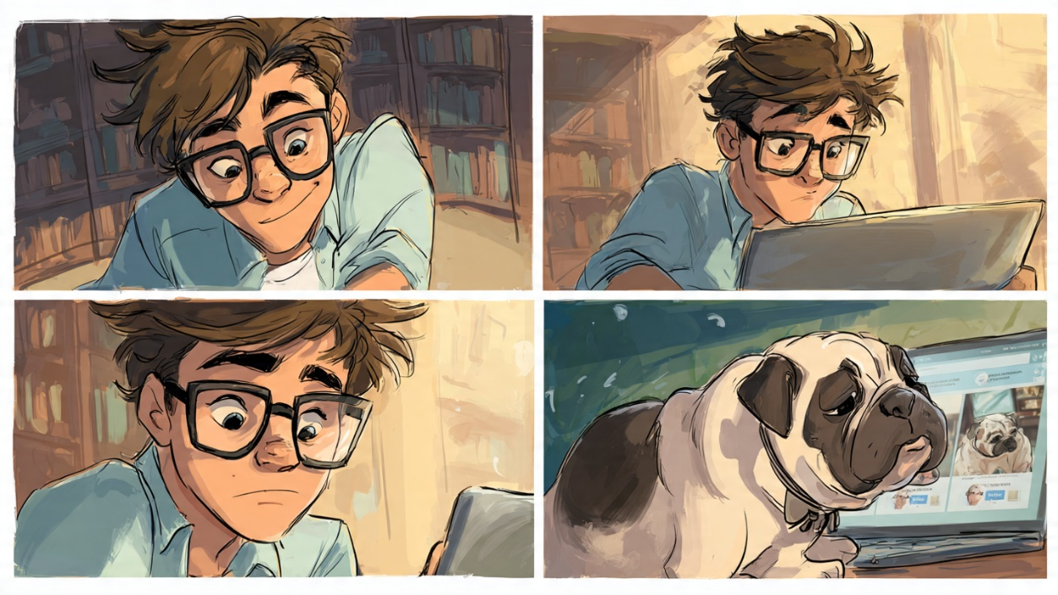
ACT 3 – DATING LAB: LEARNING BY WATCHING (2:00–3:20) — NEW, FUNNY
Scene 7 (2:00-2:20) – Back Inside Embarrassed, Kai ducks back into library, opens laptop. He types "how humans match"
Scene 8 : KAI opens SoulMatch dating app. For comic relief, a pop-up ad: "PawMatch – find love for your dog" — he clicks it by accident.
Scene 9 : (2:20-2:50) Visual: split screen – left: humans swiping, right: a bulldog in a bowtie swiping on poodles.
Scene 10 : Kai chuckles. Thought bubbles appear around his head (we SEE his mapping):
Bubble 2: "Static model" → arrow to screen: U = X\beta + \epsilon
Bubble 3: "Dynamic" → arrow to screen: "2 weeks later..."

Scene x (2:50-3:20) – Zoom into our example (through KAI perspective looking in the laptop) (visual will be like KAI thinking in his head and try to map what he read)
[This part should put our code example how the static utility and dynamic utility help understand user preferences of picking their mate, this will help KAI to understand “Why” LENA love him and “What if” that thing change what will happen] [required] but need to transform the finding into animation format first.
Then eventually, from the result KAI will know what to do next and try to approach to lena (with his new policy) and try to make her fall in love with himself again.

